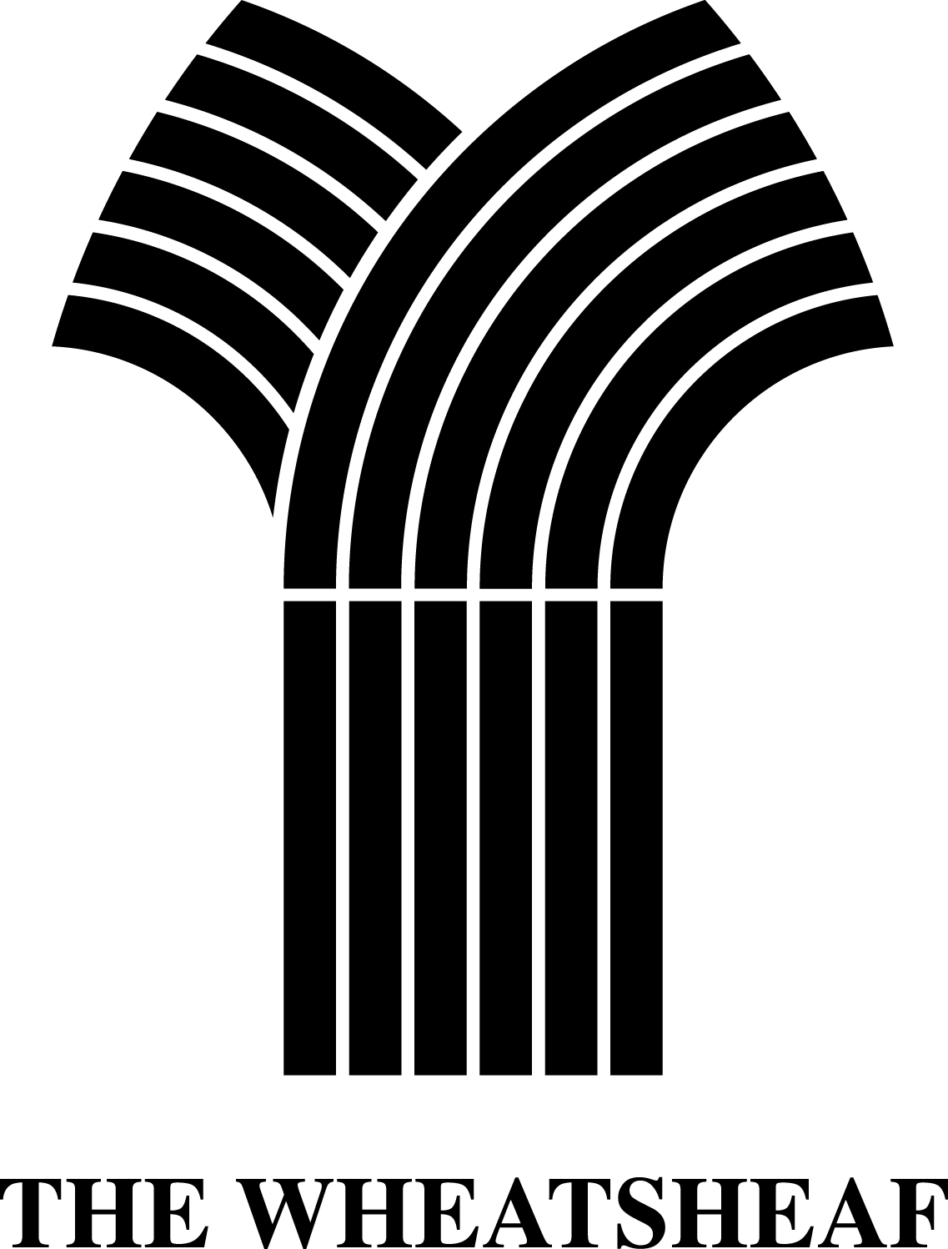
Starters
Deep Fried Camembert with a Cumberland Sauce and salad £9.00 (V)
Scampi, salad & lemon £8.00
Homemade Soup of the day £9.00
Ciabatta bread, marinated olives, olive oil and balsamic dip £9.00 (V)

Mains
Local Gammon and egg, chips and side salad £17.50
8oz Wheatsheaf burger with relish, chips, onion rings and salad £17.50
Add cheese and bacon £18.50
Apricot and Goats Cheese Nut Roast served with chips and salad £16.50 (V)
Mushroom, Cranberry and Brie Wellington served with chips and salad £16.50 (V)
(20 minute cooking time)

North Atlantic Scampi in a basket served with salad and chips £16.00
Lamb Shank with a redcurrant and mint jus served with mash potato and peas £19.50
Steak, Guinness, and mushroom pie with chips and peas £18.50
Oxfordshire sausage, mash, onion gravy and peas £17.50
Lambs Liver, bacon, mash, peas and onion gravy £17.50
Ultimate Fish pie and peas £18.50
Squash, cranberry and red onion tagine served with chips and salad £16.50 (GF and Vegan)
‘The Catch’ - lightly battered cod, or grilled, with triple cooked chips and peas £18.50
Thick Cut Rib Eye Steak served with ,mushrooms, tomatoes, onion rings, chips and peas £29.50
A 10% discretionary service charge is applied to tables of 6 or more

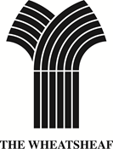
Light Lunch
Baguettes all served with chips and salad
Stilton and pancetta/ Brie and pancetta with an onion marmalade £10.00
Prawns in a marie sauce £10.50
Tuna and spring onion £10.00
Cheese and home cured ham £10.00
Steak and red onion £11.00
BLT £10.00
Home cured ham £9.50
Cheese £9.50
Various toasted sandwiches also available £9.50

Jacket Potatoes served with salad
Prawn £10.50
Tuna and spring onion £9.50
Stilton and Bacon £9.50
Cheese £9.00
Cheese and beans £9.50
Ham £9.50
Cheese and home cured ham £10.00

A 10% discretionary service charge is applied to tables of 6 or more

